Assignment – 05
Update commands
- Write a SQL statement to change the email column of the employees table with 'not available' for all employees.
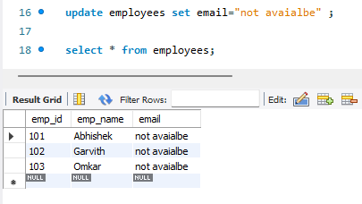
- Write a SQL statement to change the email and commission_pct column of employees table with 'not available' and 0.10 for all employees.
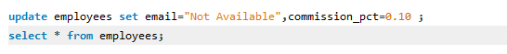
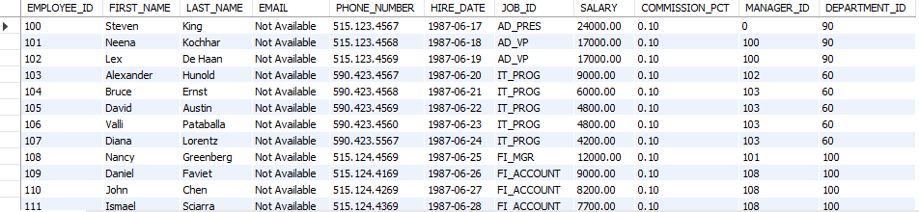
- Write a SQL statement to change the email and commission_pct column of the employees table with 'not available' and 0.10 for those employees whose department_id is 110.
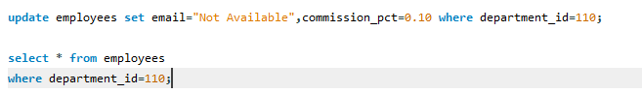
- Write a SQL statement to change the email column of the employees table with 'not available' for those employees whose department_id is 80 and gets a commission_pct is less than .20
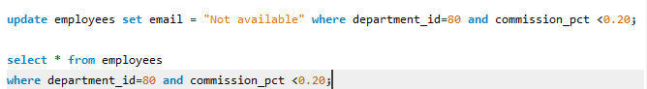
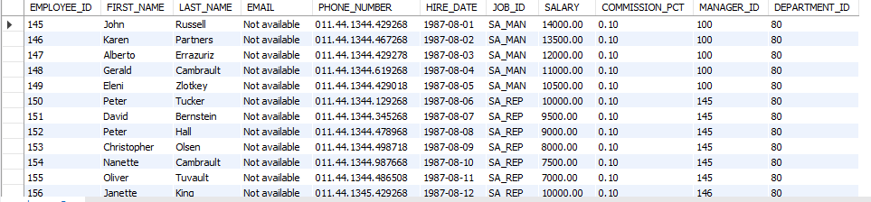
- Write a SQL statement to change the email column of the employees table with 'not available' for those employees who belong to the 'Accounting' department.
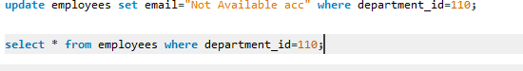
- Write a SQL statement to change the salary of an employee to 8000 whose ID is 105, if the existing salary is less than 5000.
- Write a SQL statement to change the job ID of the employee whose ID is 118, to SH_CLERK if the employee belongs to the department, whose ID is 30, and the existing job ID does not start with SH.
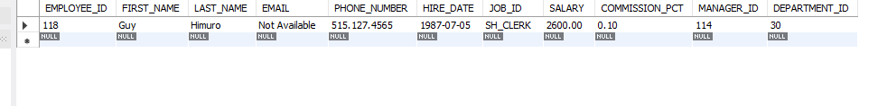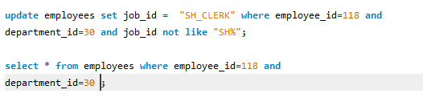
- Write a SQL statement to increase the salary of employees under the department 40, 90 and 110 according to the company rules that salary will be increased by 25% for department 40, 15% for department 90 and 10% for department 110 and the rest of the departments will remain the same.
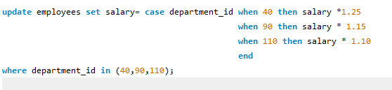
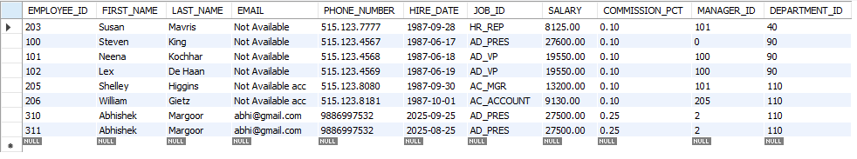
- Write a SQL statement to increase the minimum and maximum salary of PU_CLERK by 2000 as well as the salary for those employees by 20% and commission percent by .10.

